Title of the Article (in English, 18 pt.)

Title of the Article (in Thai, 20 pt.)
¹Author’s Name, ²Co-author’s Name, ³Co-author’s Name (in English, 16 pt.)
¹Author’s Name, ²Co-author’s Name, ³Co-author’s Name (in Thai, 16 pt.)
¹Affiliated Institution and Country (in English, 14 pt.)
¹Affiliated Institution (in Thai, 14 pt.)
¹Corresponding Author’s Email: …………………… (14 pt.)

Abstract (English, 18 pt., not exceeding 300 words)
(16 pt.) Present the research findings, perspectives, and insights that reflect solutions, options, new knowledge, principles, and academic approaches. Write concisely and clearly with organized categories, separated points, and issues.
............................................................................................................................................................................................................................................................................................................................................................
............................................................................................................................................................................................................................................................................................................................................................
............................................................................................................................................................................................................................................................................................................................................................
Keywords: keyword; keyword; keyword (3–5 words separated by semicolons)
..............................................................................................................................................................................

Abstract (Thai, 18 pt., not exceeding 300 words)
(16 pt.) Translate directly from the Thai abstract. Preserve the original word structure and sentence format. Do not summarize, paraphrase, or expand. Maintain the same numbering, paragraphing, punctuation, and headings as in the Thai version.
............................................................................................................................................................................................................................................................................................................................................................
............................................................................................................................................................................................................................................................................................................................................................
............................................................................................................................................................................................................................................................................................................................................................
..............................................................................................................................................................................
Keywords: keyword; keyword; keyword (3–5 words separated by semicolons)
..............................................................................................................................................................................

Introduction (18 pt., content 16 pt.)
(16 pt.) Background, context, and the problem statement of the study/case/area (with references).
............................................................................................................................................................................................................................................................................................................................................................
Theoretical foundations, concepts, academic theories, practical guidelines, and problem-solving or development standards (with references).
............................................................................................................................................................................................................................................................................................................................................................
Motivation to conduct the study: expected value, significance, and benefits of the research (with references).
............................................................................................................................................................................................................................................................................................................................................................

Main Content (18 pt., content 16 pt.)
Present the context, background, and issues with academic clarity. Structure the content by importance (major and minor issues), using organized numbering, paragraphs, and punctuation for clarity and easy understanding (with references).
............................................................................................................................................................................................................................................................................................................................................................
Present key ideas, theories, and practical approaches that reflect new knowledge in a categorized, systematic, and step-by-step manner as an academic alternative for solving problems or promoting development (with references).
............................................................................................................................................................................................................................................................................................................................................................

Conclusion (18 pt., content 16 pt.)
Summarize the overall content in essay format without numbering or subheadings. Do not use italics, bold, images, or models. The length should be about half a page. No references are required.
............................................................................................................................................................................................................................................................................................................................................................
............................................................................................................................................................................................................................................................................................................................................................
............................................................................................................................................................................................................................................................................................................................................................
References (18 pt., content 16 pt.)
There should be at least six references. All sources cited in the content must appear completely and accurately in the reference list. Use APA 7th edition style and arrange alphabetically A–Z. Do not include any sources that are not cited in the article. Refer to the provided sample for formatting guidelines.

Sample References in APA 7th Edition Format
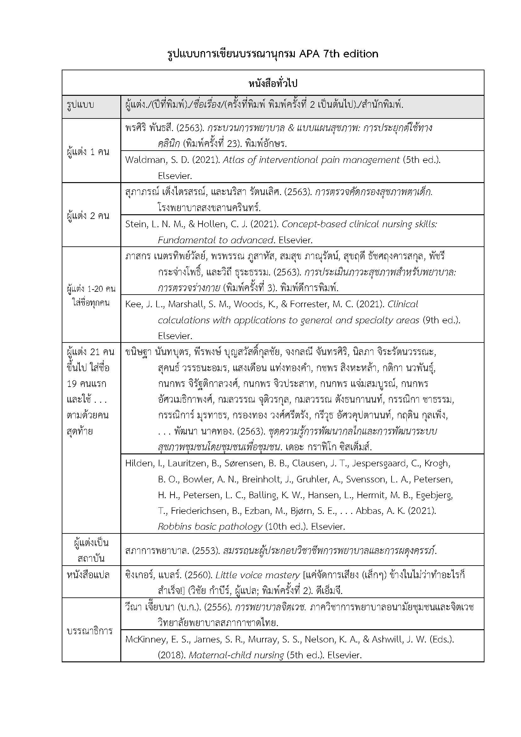

How to Arrange References
Use the same principles as standard dictionary order. Thai words are arranged by consonant first, then vowel, in the following order:
ก ข ค ฅ ฆ ง จ ฉ ช ซ ฌ ญ ฎ ฏ ฐ ฑ ฒ ณ ด ต ถ ท ธ น บ ป ผ ฝ พ ฟ ภ ม ย ร ฤ ฤา ล ฦ ฦา ว ศ ษ ส ห ฬ อ ฮ
For words beginning with the same consonant, sort by vowel order:
อะ อัว อัวะ อา อำ อิ อี อื อุ อู เอะ เอ เอาะ เอา เอิน เอีย เอียะ เอือ เอือะ แอ แอะ โอะ โอ ใอ ไอ

