Title (English 20 pt.)
Title (Thai 18 pt.)

¹Author’s name-surname, ²Co-author’s name-surname and ³ Co-author’s name-surname (English 16 pt.)
¹Author’s name-surname, ²Co-author’s name-surname and ³ Co-author’s name-surname (Thai 16 pt.)
¹Affiliated Institute, Country (English 14 pt.)
¹Affiliated Institute (Thai 14 pt.)
¹Corresponding Author’s Email: ………………………. (14 pt.)

Abstract (18 pt, not exceeding 300 words, 2 paragraphs)
(16 pt) This research article states the research objectives, type of research, population and area, and data analysis methods (statistical, descriptive).
..........................................................................................................................................................................................................................................................................................................................................................................................................................................................................................................................................
The research findings, according to the order of objectives, are as follows:
- ................................................................................................................................................................
- ................................................................................................................................................................
- ................................................................................................................................................................

Keywords: keyword; keyword; keyword (3–5 words, separated by semicolons)

Abstract (Translated Version) (18 pt, not exceeding 300 words)
(16 pt) Translate the Thai abstract with precise sentence and word structure. Do not summarize or expand. Keep the numbering, paragraphs, punctuation, and formatting consistent with the Thai version.
............................................................................................................................................................................................................................................................................................................................................................
............................................................................................................................................................................................................................................................................................................................................................
............................................................................................................................................................................................................................................................................................................................................................

Keywords: keyword; keyword; keyword (3–5 words, separated by semicolons)

Introduction (18 pt, content 16 pt)
(16 pt) Background, context, and the problem of the study (with references)
............................................................................................................................................................................................................................................................................................................................................................
Study area or case (with references)
............................................................................................................................................................................................................................................................................................................................................................
Concepts, theories, academic principles, and practices used to address the issue or promote development (with references)
............................................................................................................................................................................................................................................................................................................................................................
Motivation for the study (should connect with the above context and relate to the objectives, expectations, and values of the research)
............................................................................................................................................................................................................................................................................................................................................................

Research Objectives (18 pt, content 16 pt)
- To ..........................................................................................................................................................
- To ..........................................................................................................................................................
- To ..........................................................................................................................................................

Research Methodology (18 pt, content 16 pt) (adjustable depending on article type)
Step 1: Literature and theoretical study
Step 2: Field study
Step 3: Key informants
Step 4: Research tools and methods
1) Interviews
2) Focus group discussions
3) Observation/Follow-up/Training
Step 5: Data collection
Step 6: Data analysis
Step 7: Research conclusion and presentation

Research Findings (18 pt, content 16 pt)
Objective 1: To ... Findings show that ...
................................................................................................................................................................................................................................................................................................................................
Objective 2: To ... Findings show that ...
................................................................................................................................................................................................................................................................................................................................
Objective 3: To ... Findings show that ...
................................................................................................................................................................................................................................................................................................................................

Research Contribution / Body of Knowledge (18 pt, content 16 pt)
The new knowledge is a synthesized body of work presented as diagrams, models, or conceptual frameworks, along with process explanations, methods, values, benefits, and practical applications. It offers actionable approaches for individual, societal, or organizational development.
............................................................................................................................................................................................................................................................................................................................................................

Conclusion and Discussion (18 pt, content 16 pt)
Written as a narrative showing links, similarities, and differences with existing theories or past studies. Findings for Objective 1 show that ... This is due to ...
............................................................................................................................................................................................................................................................................................................................................................
Which aligns with the theory/research of ... (with reference)
Findings for Objective 2 show that ... This is due to ...
............................................................................................................................................................................................................................................................................................................
Which aligns with the theory/research of ... (with reference)
Findings for Objective 3 show that ... This is due to ...
............................................................................................................................................................................................................................................................................................................
Which aligns with the theory/research of ... (with reference)

Suggestions (18 pt, content 16 pt)
1. Suggestions from the research:
1.1 ..................................................................................................
Thus, relevant organizations should implement the following: ..................................................................
1.2 ..................................................................................................
Thus, relevant organizations should implement the following: ..................................................................
1.3 ..................................................................................................
Thus, relevant organizations should implement the following: ..................................................................
2. Suggestions for future research:
2.1 Future research should focus on the topic of …
2.2 ..................................................................................................
2.3 ..................................................................................................

References (18 pt, content 16 pt)
For research articles, at least 8 references should be included. All sources cited in the main body must be listed here in full and formatted according to APA 7th edition, arranged alphabetically (A–Z). Do not list any sources that were not cited in the body of the article. Follow the reference style guidelines or attached examples.

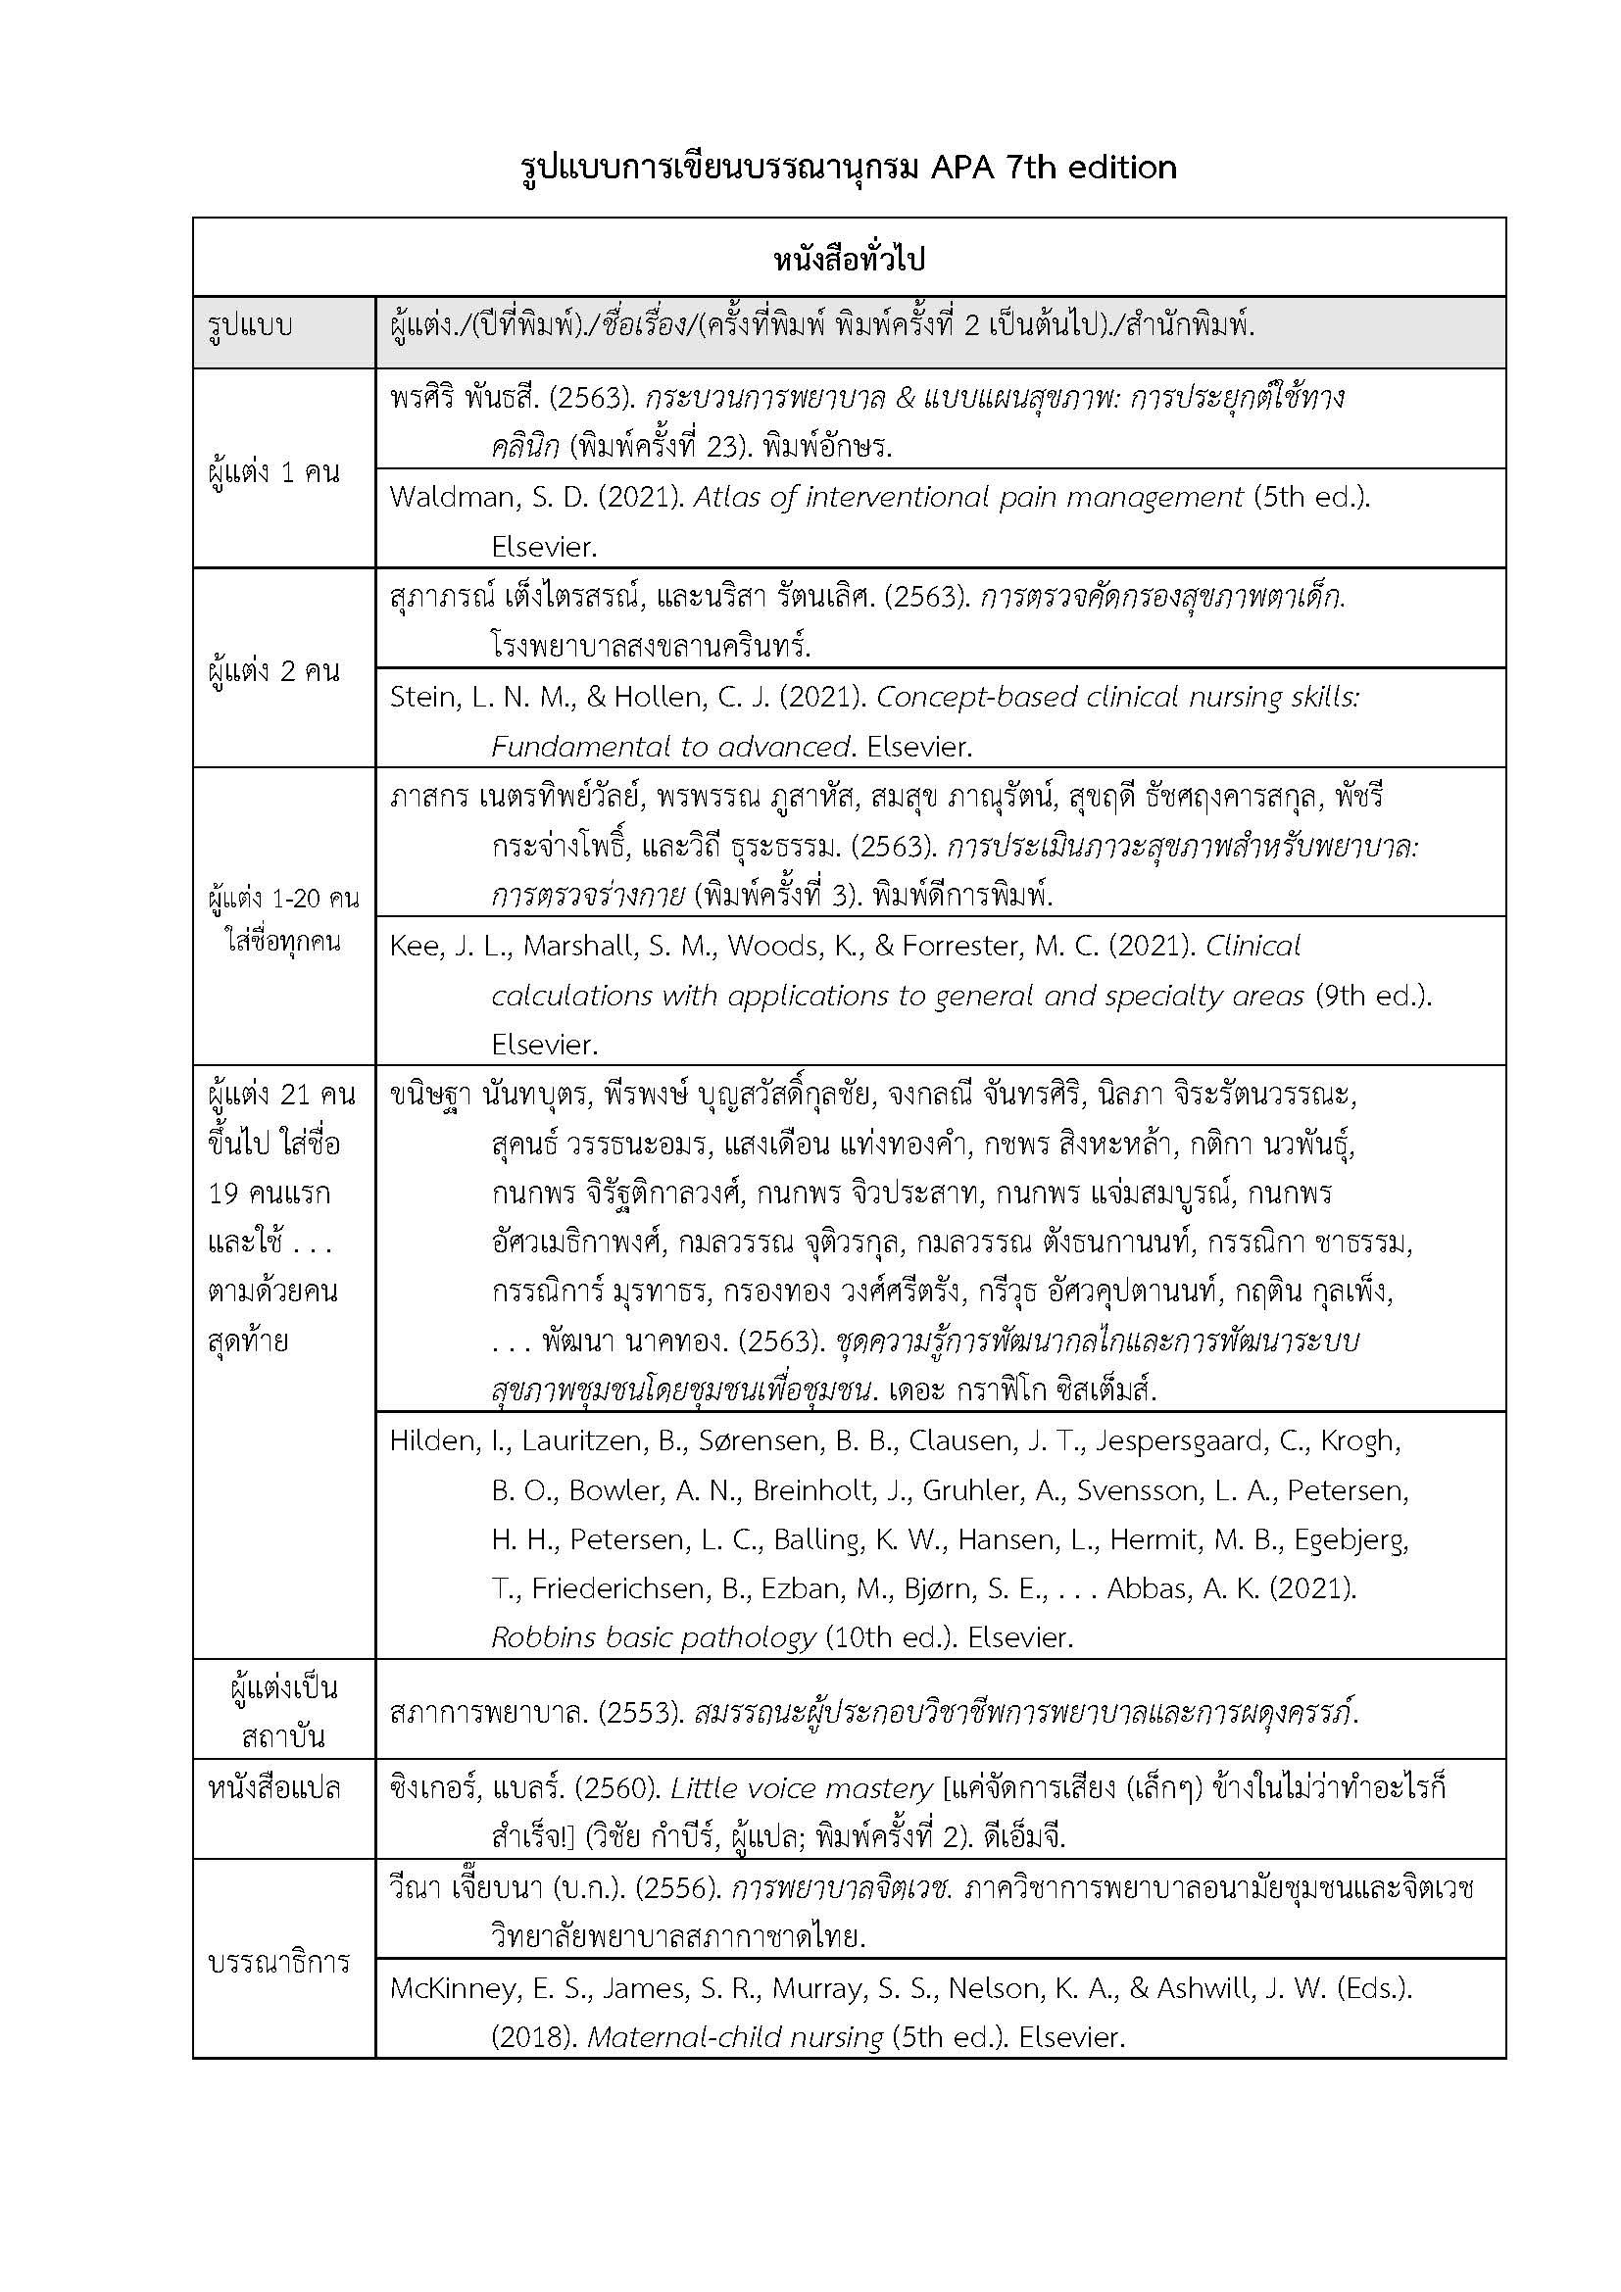
Basic examples of references in APA 7th edition for the reference list.

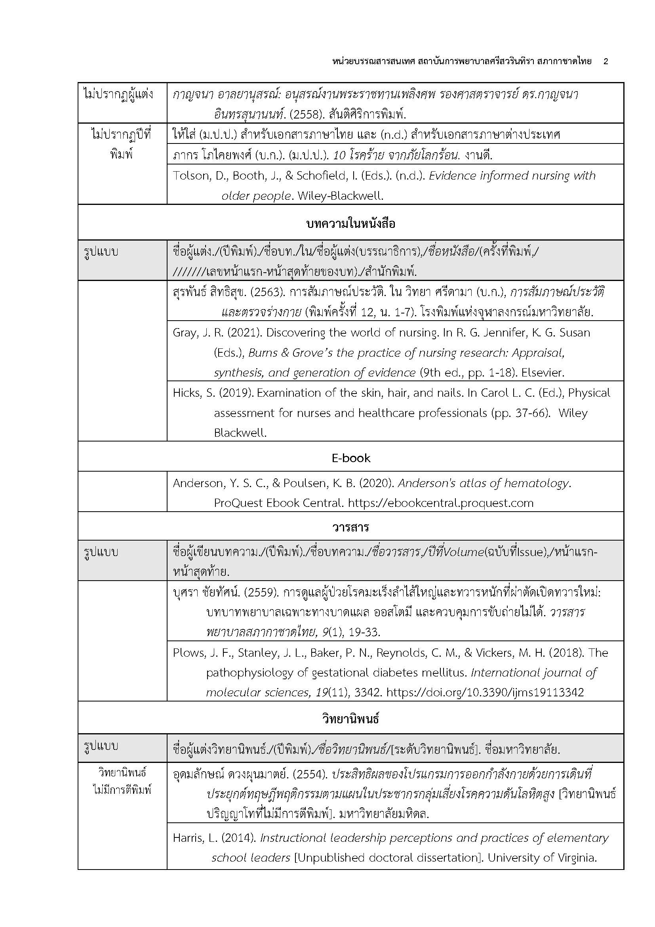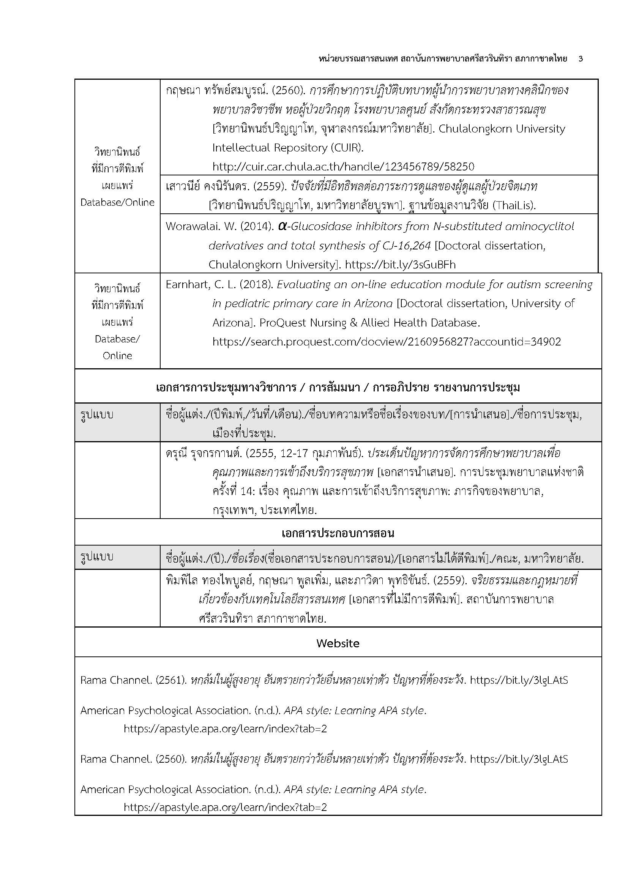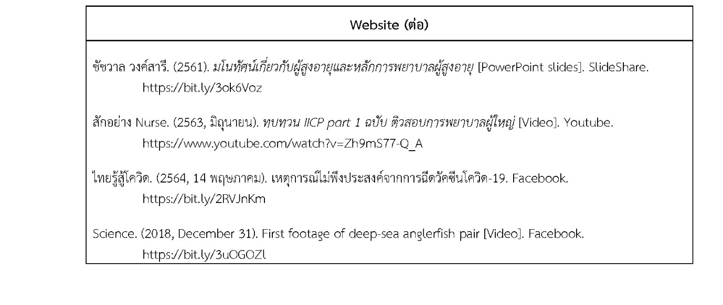
How to Alphabetically Arrange References
The principle follows the same method as arranging words in a dictionary, which is widely accepted. Words are ordered based on consonants first, followed by vowels, in the following Thai alphabetical order:
ก ข ค ฅ ฆ ง จ ฉ ช ซ ฌ ญ ฎ ฏ ฐ ฑ ฒ ณ ด ต ถ ท ธ น บ ป ผ ฝ พ ฟ ภ ม ย ร ฤ ฤา ล ฦ ฦา ว ศ ษ ส ห ฬ อ ฮ
For words beginning with the same consonant, arrange them further by the vowel forms in this order:
อะ อัว อัวะ อา อำ อิ อี อื อุ อู เอะ เอ เอาะ เอา เอิน เอีย เอียะ เอือ เอือะ แอ แอะ โอะ โอ ใอ ไอ

